Listening a dialogue.

Shopping for clothes



**Write the words that you will hear.**

1. Shop assistant: We’ve got it in white, black, _______ . What size do you want?

2. Shop assistant: That’s £10.95. Would you like to pay by credit  ______?

3. Shop assistant: OK, thanks, that’s nine pounds, 5 p change and here’s  ______________.

4. Customer: OK, red. Can ___________________ ?

5. Shop assistant: Yes, of course. The ____________ are over there.

6. Shop assistant: OK, thanks, that’s nine pounds, 5 p change and here’s ____________.

7. Shop assistant: OK, in medium we’ve  _______ and red.

8. Customer: Cash please. Here’s  _________________.

Furniture

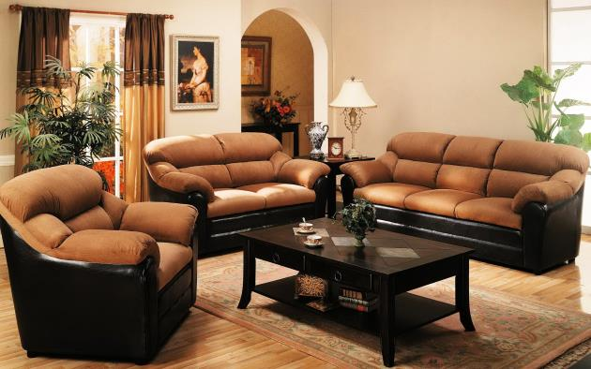

**Write the words that you will hear.**

1. Making furniture used to be ____________.

2. You can pay ____________ the guys assemble your furniture for you, but I like doing it myself.

3. I’ll mix modern ideas with traditional ones. I’d like to start a ____________ furniture that helps the environment.

4. I love going round ____________ and looking at all the beautiful sofas and chests and cabinets from hundreds of years ago.

5. Nowadays a lot of furniture  _____________.

6. I’m studying interior design and would like to start my own furniture  _______ one day.

7. They don’t __________ furniture like they used to.

Perfume



**Write the words into the gaps.**

1. It’s one of the worst _____________ in the world.

2. I thought the original idea of perfume was to cover the smell of ____________  when we didn’t take a bath.

3. I think the perfume _________ making huge amounts of money.

4. It makes me feel a little sick and I worry about the  ___________ in it.

5. Everybody showers or takes  ________ these days, so there’s no need for perfume.

6. I hate it when someone walks past me with really  ­________ or cologne.

Shopping



**Write the words into these gaps.**

1. I know a lot of people who like window shopping – just __________  shops without wanting to buy anything.

2. My plan for shopping is ‘quickly in, quickly out’. If I have to go shopping, I go in the morning on a   _____________.

3. It seems as though all of the world’s _____________ are in the same store as you.

4. There’s nothing more boring than wandering  __________ malls.

5. I was happy when  ____________ came along.

6. Shopping must be one of the world’s most   __________.

7. The worst time to go shopping is on a Saturday afternoon  ________ .

Shopping for clothes 2



**Curtis and Spencer talk about their fashion style and the clothes they like to buy and wear.**

**Write true or false.**

1. Spencer has a few shoes.

2. Curtis has a few shirts that were bought just when he/she began working after college.

3. Spencer can buy the same things of different colors.

4. Curtis doesn’t spend a lot of, money on clothes.  
  
5. Curtis didn’t buy shirts after college.

6. Curtis has many hats.

7. Spencer wear that same things with the same colour.